Debugging Note Taking Application:

Actual code given:

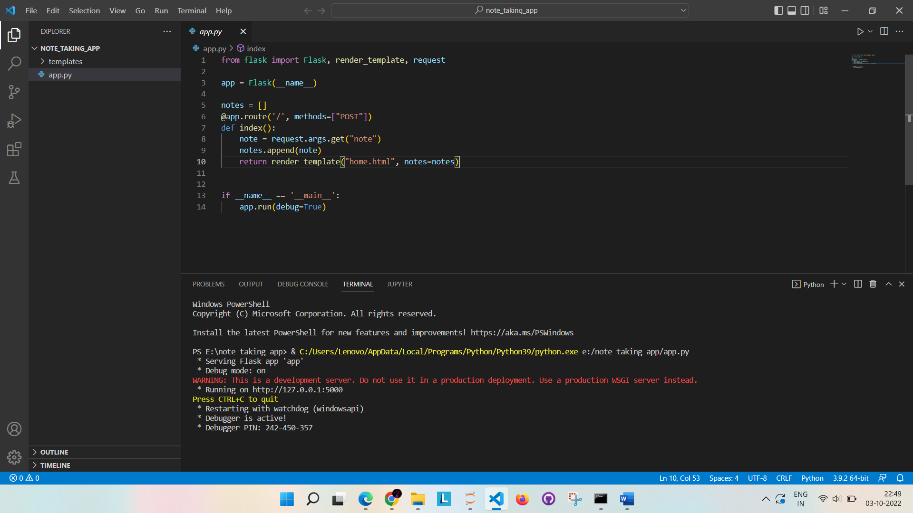

Output:

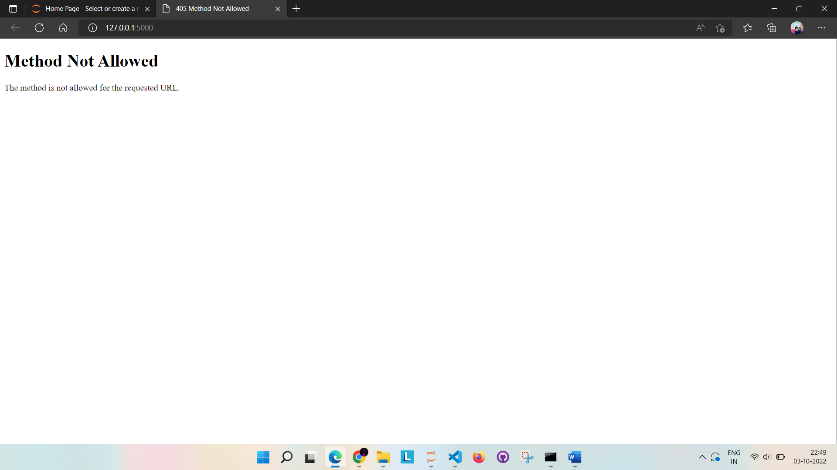

Reason:

request.args.get("note")

flask.request.args returns the part in the URL after the question mark.

And the method is by default GET.

WIth the method GET we will get all the information which was entered through form in the URL after the question mark.

But if you see, the .py file

@app.route('/', methods=["POST"])

It is taking the method as POST but not GET.

So code is modified as

@app.route('/', methods=['GET', 'POST'])

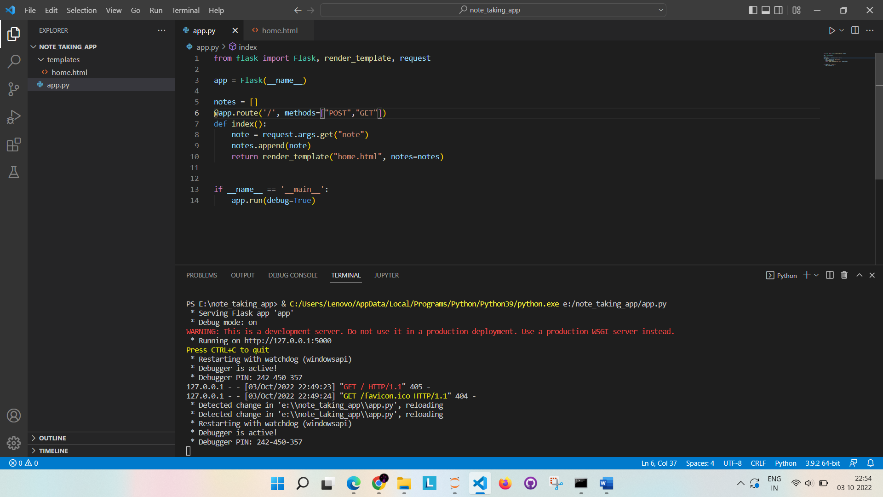

Output Now:



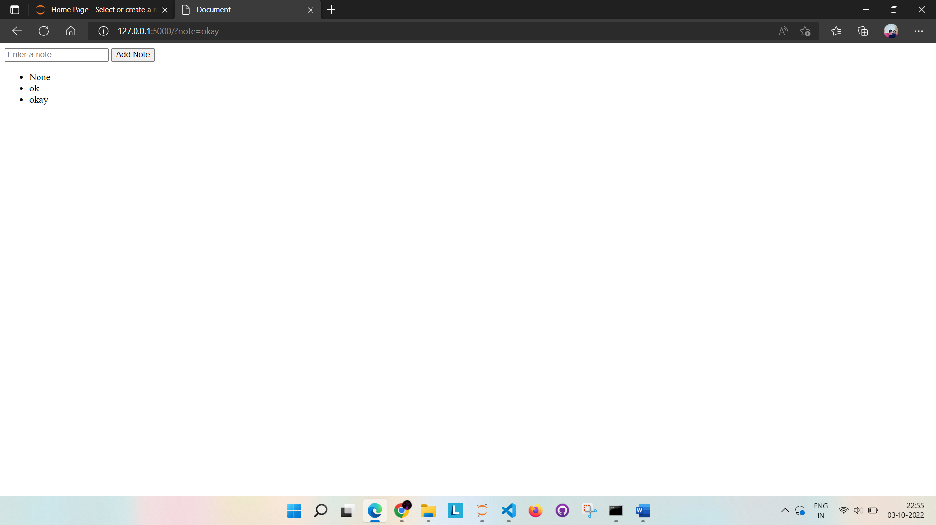

Also w.k.t flask.Request.args returns the part in the URL after the question mark.

flask.Request.form returns the data which was entered through the form.

So if we change the method to POST in home.html we need to use request.form in py file.

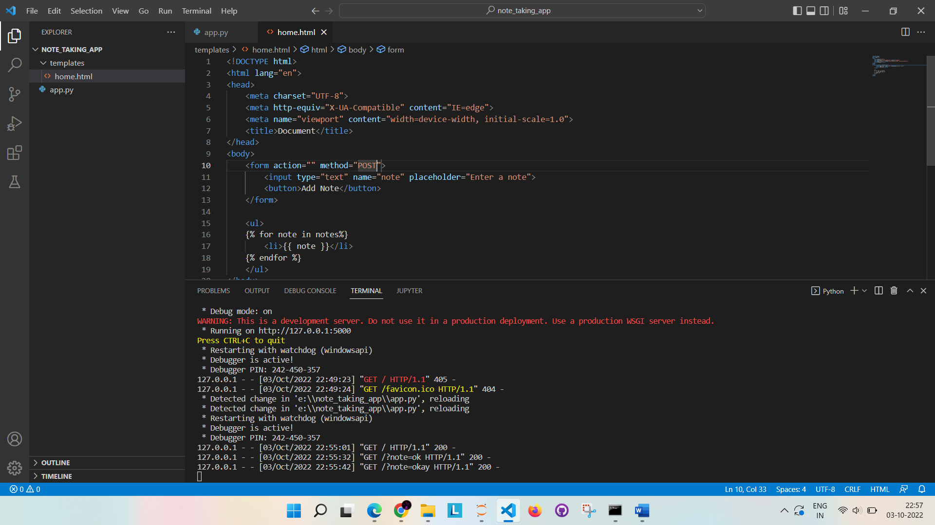

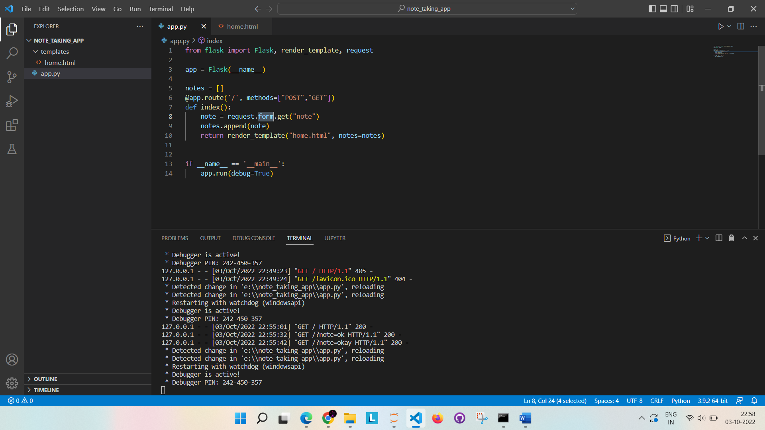

Output:

